Food Ordering System

HCL Training - Team 03

Contents

1. Introduction 1
2. Design and Detailed Technical Updates 1

2.1 Process Model

2.1.1 Use Case Model

# Introduction

The food ordering system is for easy ordering purpose of food ordering process with the shop and the customers. Here the customers will be able to register and login to the system to set orders by selecting available food items at the moment.

# Process Model – Use Case Diagram

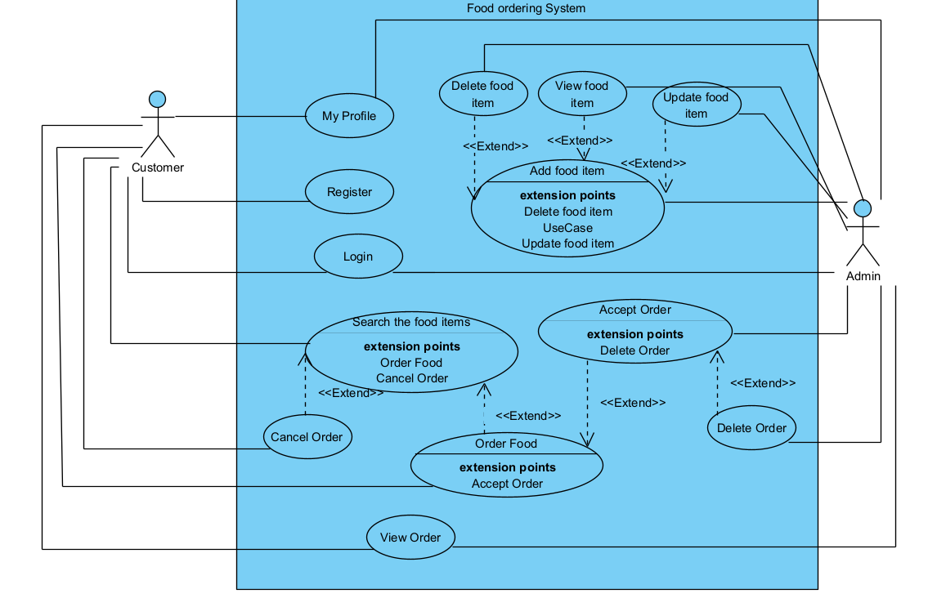

# Process Model – Use Case Scenarios

|  |  |
| --- | --- |
| Brief Description | Customer Login |
| Basic Flow | This use case describes how customer is allowed to login to the system.   1. Customer has to login to the system to order the food through system. 2. To login to the system customer has to provide username and password which were given when registering to the system.   After successful login, customer will be able to see the relevant home page. |
| Alternate Flow | If the customer cannot remember the password, these steps can be followed.   1. Customer can select Forgot Password option. 2. Customer can give their email to send one time password through email. 3. Customer can provide that password and login to the system.   The customer can login via email account. |
| Validation | 1. Username and password both should be correct to access to the system.  2. Username or password fields should not be empty. |
| Pre - Conditions | User must be a registered person to the system via register option. |
| Post - Conditions | The system should display the relevant home page. |

|  |  |
| --- | --- |
| Brief Description | Customer Registration |
| Basic Flow | This Use Case allows new Customers to Register in to the system.   1. Customer need to register in to the system in order to order the food. 2. The following fields are required during registration.  * First Name * Last Name * Email * Phone Number * Password * Confirm Password  1. After the successful data input customer will receive a success message. |
| Alternate Flow | 1. The System will validate the provided data in each field. For any invalid data the system will provide an error message. |
| Validation | 1. First name and Last name fields are required minimum 3 and maximum 15 Characters. Cannot Include alphanumeric. 2. Valid email should be provide. 3. Phone number field cannot enter any letters or characters. 4. Password should be maximum 8 characters |
| Pre - Conditions | Customer should have network connection and browser. |
| Post - Conditions | Customer should get successful message. |